**Skrill**

1. To Create an account, go by link: https://www.skrill.com/en/.

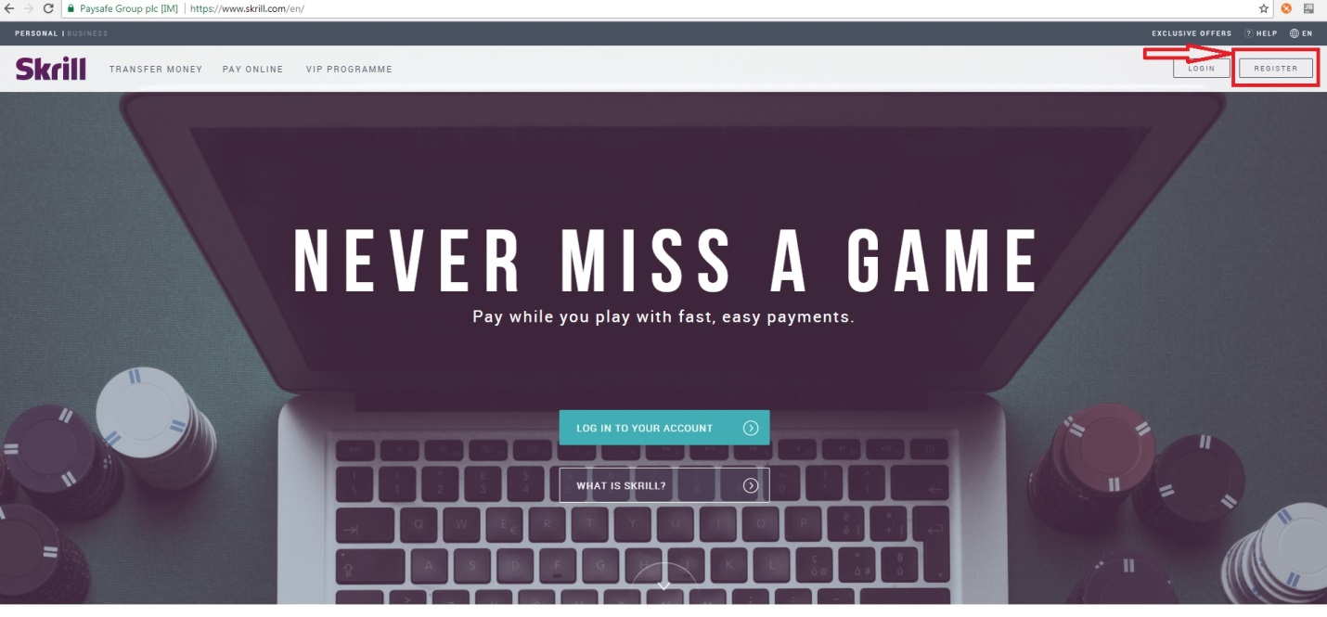

1. Enter your e-mail and password.

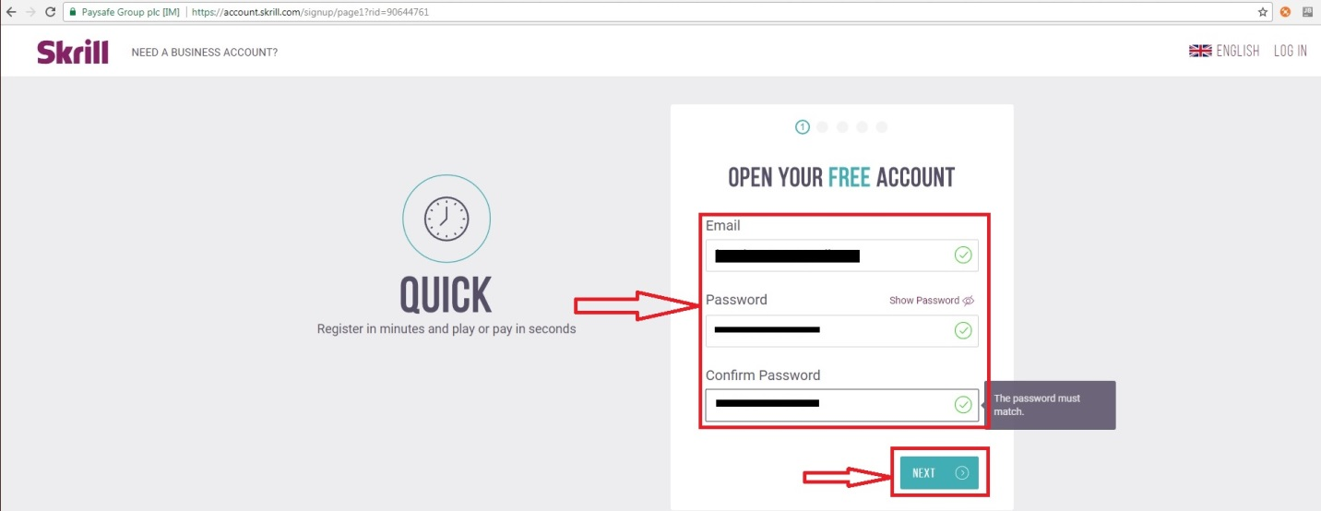

1. Enter your Name, Surname and date of birth.

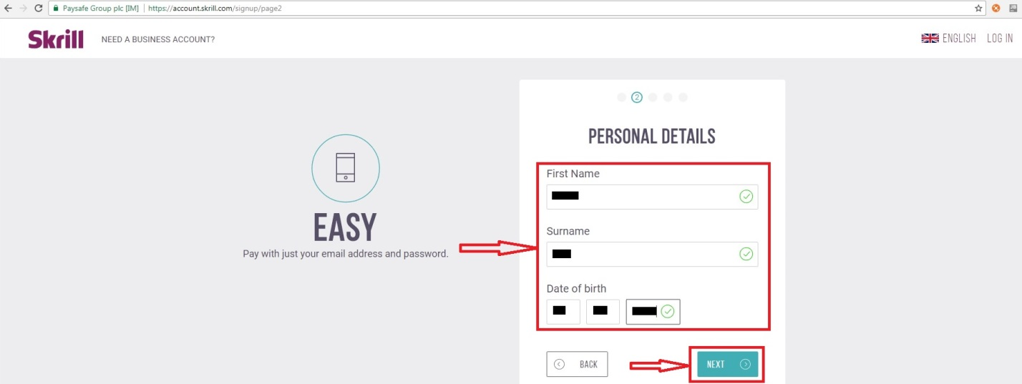

1. Enter your country and walute currency.

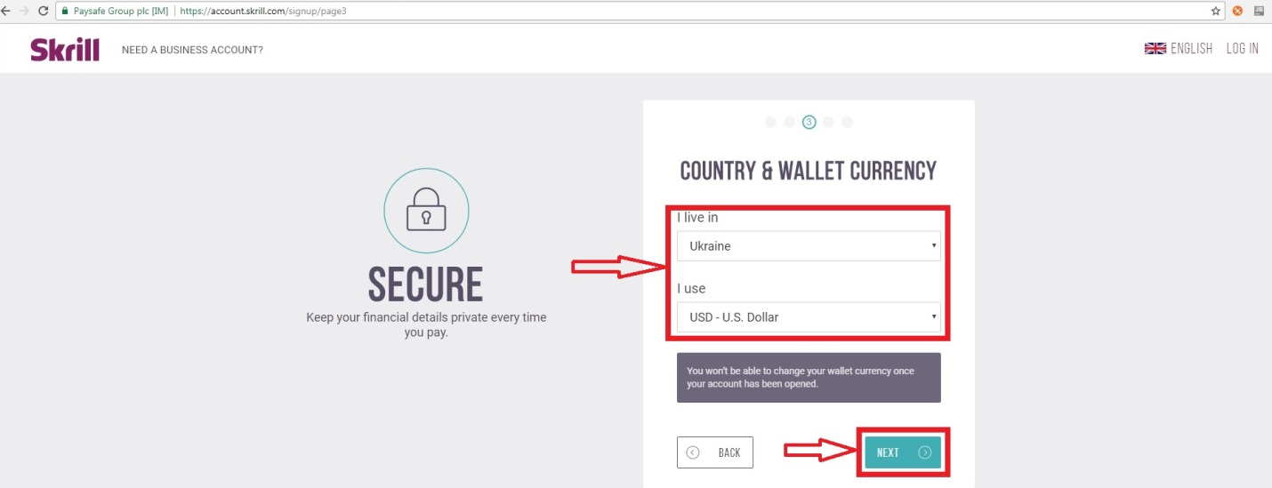

1. Enter your address.

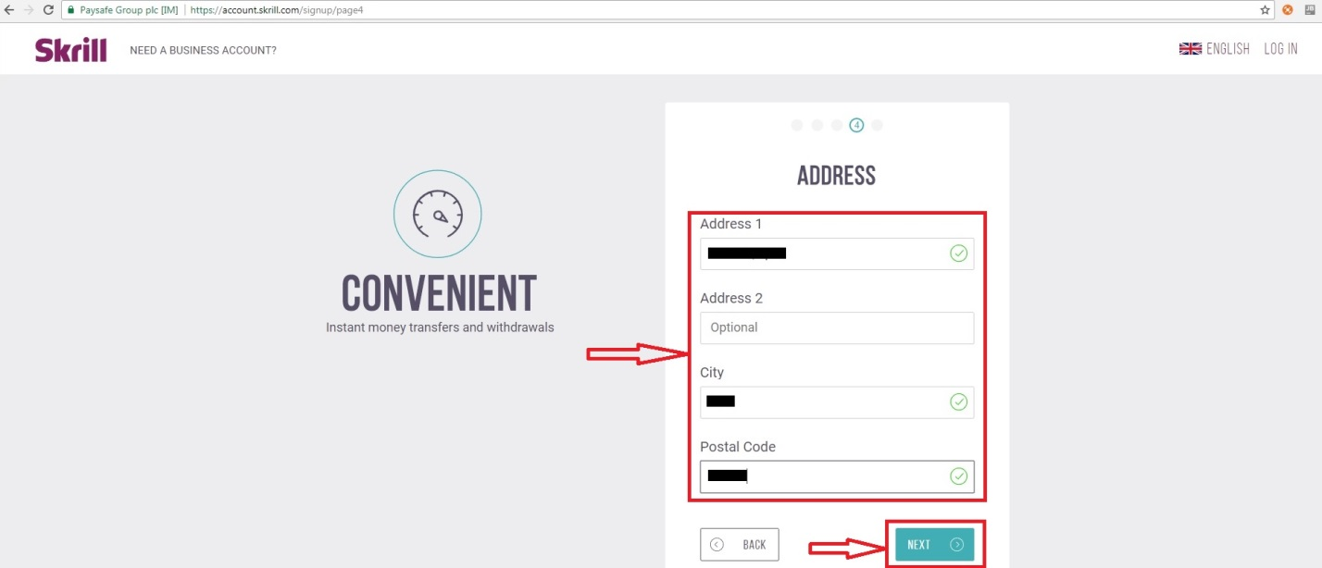

1. Enter your phone number and press Open account.

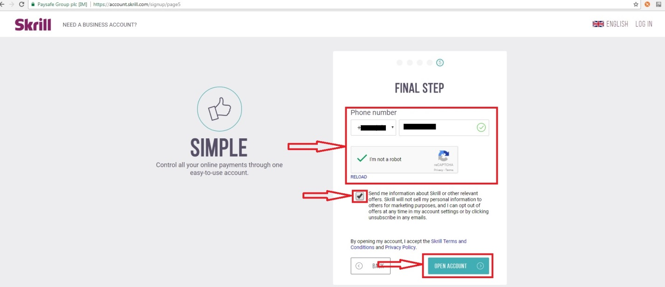

1. Confirm your e-mail and start to use your account.

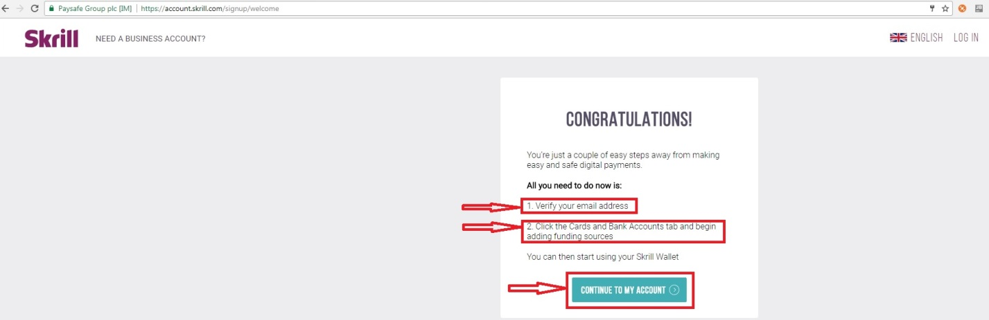

1. Your account’s ID.

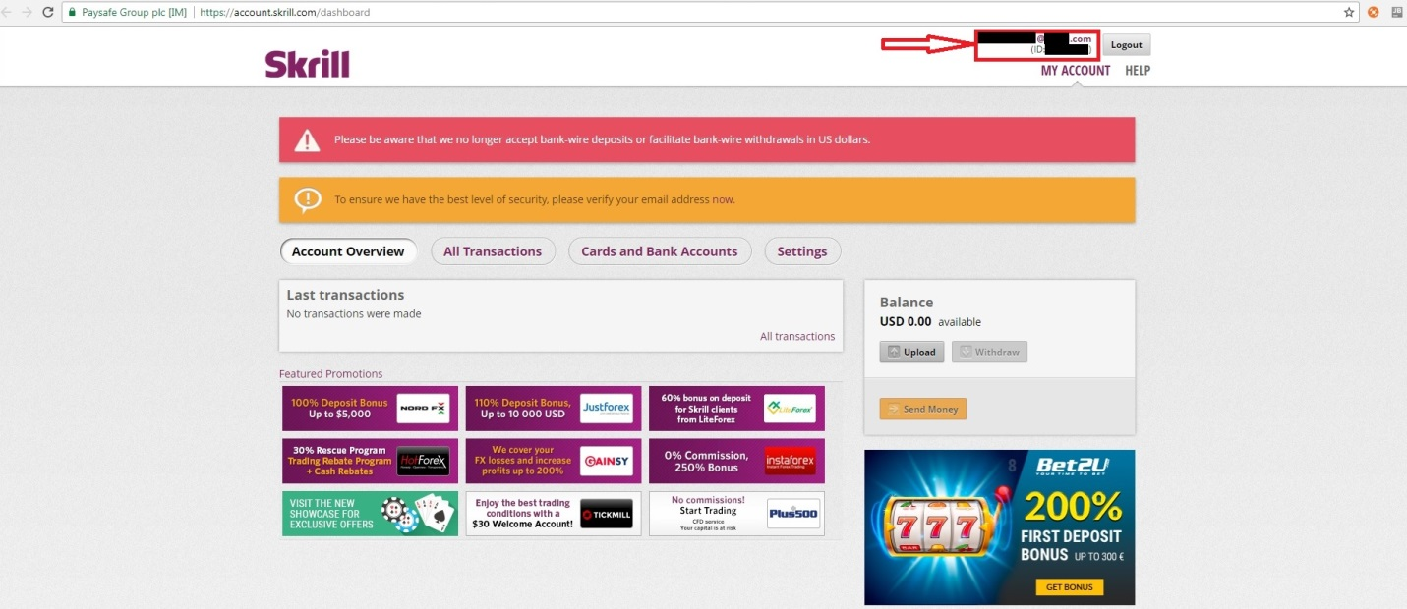

**To enable the MQI and / or API:**

1. Log in to your Skrill account at www.skrill.com.

2. Go to **Settings > Developer Settings**. Check the **Enable service** checkbox next to the services you want to enable.

4. Specify at least one IP address from which requests will be made. All requests from other IP

addresses are denied. Access can be granted to:

• A single IP address (e.g. 192.168.0.2)

• Multiple IP addresses, separated by space (e.g. 192.168.0.2 10.0.0.2)

• A subnet in CIDR notation (e.g. 192.168.0.0/24)

Enter a list of IPs or at least one IP address (or an IP range) in the text fields in the

corresponding sections.

5. To apply your changes, click **Save**.

**Separate API and MQI password**

You must use a separate password for making API or MQI requests. This ensures that the password

you use to access your Skrill Digital Wallet account can be changed without affecting the API or MQI.

**To enable a separate API/MQI password:**

1. In the **Settings > Developer Settings** area, check the **Enable separate API/MQI password**

checkbox.

2. Enter a new password and confirm it in the **Re‐type password** box below.

3. Click **Save**.

**Secret word**

The secret word is used for the following:

• To construct the msid digital signature parameter. This parameter is sent to the return_url if the

secure return_url option is enabled for your merchant account. This signature is used to verify

the authenticity of the information sent to the return_url once payment is complete.

• To create the digital signature parameters used to verify the authenticity of the payment status

information that Skrill sends to the status_url .

• For the email check tool to carry out anti‐fraud checks on email addresses.

**To insert a secret word:**

1. Go to the **Settings > Developer Settings** section of your Skrill account.

2. In the **Secret Word** field, enter your secret word. The following restrictions apply:

• All characters must be in lowercase

• The length should not exceed 10 characters

• Special characters are not permitted (e.g. ***@, %, $,*** etc.)

**Note**: If you insert any uppercase symbols, they will automatically be converted to lowercase.

3. To apply your changes, click **Save**.